Firm-level internal financing availability and investment decisions: Evidence from panel VAR

Henan Xu

Instructor: Dr Tanggang Yuan

## Abstract

In this paper, vector autoregression (VAR) is applied to firm-level panel data from Chinese companies among 6 industries to study the dynamic relationship between firms’ financial conditions and investment, that is the relationship between 4 variables {**SKB**, **IKB**, **CFKB**, **TOBINQ**}. Furthermore, we use impulse-response functions (IRF) simulated using Monte-Carlo to find individual responses to shocks to individual variables, as well as variance decompositions to investigate the predictability of one variable to the others. Our findings include some intuitive results but the data needs further filtration as there is a lack of significance in most results.

**1.Introduction**

In accordance with the neoclassic theory of investment, **investment**, defined as **the addition to the stock of capital of firms and enterprises**, is determined by **the marginal product of capital (MPK)** and the **marginal cost of capital (MCK).** **Marginal product of capital (MPK) measures the addition to the production by using an additional unit of capital, labour and technology with other factors remaining constant**. Due to **the law of diminishing returns**, marginal product of capital declines as more units of capital are used for production, other factors being held constant.  Therefore, with the objective of profit maximization, firms make decisions of investment **to the point** where the **marginal product of capital (MPK)** equals the **marginal cost of capital (MCK).** However, market inefficiencies resulting from **asymmetric information** remain largely unexplored. In economics and corporate finance theories, **information asymmetry predominantly deals with the study of decisions in transactions where one party has more or better information than the other**. Examples of fellow market frictions include problems like **moral hazard** and **adverse selection** where **moral hazard** occurs **when someone increases their exposure to risk when insured** and **adverse selection** refers to the situation **when traders with better private information about the quality of a product will selectively participate in trades which benefit them the most, at the expense of the other trader.**

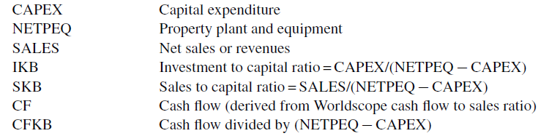Consequently, in the context of this paper, firms’ investment levels are not uniquely determined by the marginal productivity of capital, as Tobin’s q-theory suggests. **Tobin’s q** is primarily concerned by **the ratio by comparing the market value of a company's equity and liabilities with its corresponding book values**. It is believed that **firms should implement increments in investment when the ratio exceeds 1, main its current level if the ratio is exactly 1 and lower level of investment if the ratio falls below 1**. Instead, we will focus on the relationship between internal financial constraints and investment levels of individual companies. There are several major variables of interest when exploring this field, including **SKB, CFKB, IKB, TOBINQ**. They are defined as follows:

Note, in the context of our paper, that **SKB** and **TOBONQ** are fundamental factors that capture the **marginal productivity of capital** as per claims of **neoclassical theory of investment** as the higher the two factors are, the higher the marginal productivity of capital is. Furthermore, investment levels, proxied by **IKB**, of individual firms are deemed, by intuition, positively correlated to **CFKB** which is representative of the availability of internal financing.

**2. Methodology**

**Panel-data vector autoregression (VAR)** is the major methodology adopted in this paper. **Vector autoregression (VAR)** is a [stochastic process](https://en.wikipedia.org/wiki/Stochastic_process) model used to capture the linear interdependencies among multiple [time series](https://en.wikipedia.org/wiki/Time_series). **VAR** models generalize the univariate [autoregressive model](https://en.wikipedia.org/wiki/Autoregressive_model) by allowing for more than one evolving variable.

In the specific VAR model of our paper, **SKB** and **TOBINQ** are fundamental factors that incorporate information about the **marginal productivity of capital** while **CFKB** is adopted as an indicator of **internally available funds** as per numerous investment models. It should be pinpointed that there are **three** major underlying assumptions. **First**, it is assumed that current shocks to the marginal productivity of capital (proxied by **SKB**) have an effect on the contemporaneous value of investment, while investment has an effect on the marginal productivity of capital only with a lag. **Another** assumption is that the effect of sales on cash flow is likely to be contemporaneous and if there is any feedback effect it is likely to happen with a lag. Finally, we assume that investment responds to cash flow contemporaneously, while cash flow responds to investment only with a lag.

The raw set of data applied in our research consists **17,128** financial years of data from numerous Chinese companies with **379** characteristics of each company each year, that is **379 variables** with **17,128 observations** which form a **17,128*379 matrix**. The set of data is to be filtered to reduce the 379 variables to primarily **SKB, CFKB, IKB** and **TOBINQ** and drop observations before the year of **1998** when cash flow statements became available from Chinese firms.

**3. Empirical results**

3.1 Data summary

|  |  |  |  |  |  |
| --- | --- | --- | --- | --- | --- |
| Summary statistics for main variables | | | | | |
| Variables | # of Observations | Mean | Standard Deviation | Min | Max |
| SKB | 13,937 | 22.13195 | 244.3001 | -5332.95 | 161494.1 |
| CFKB | 14,075 | 1.038194 | 244.3001 | -11826.6 | 21172.83 |
| IKB | 14,075 | 2.389381 | 191.1836 | -1030.25 | 18837.21 |
| TOBINQ | 13,559 | 2.482584 | 103.3496 | -23.8407 | 11822.98 |

Table 1

Table 1 summarizes statistical descriptions of the main variables being analyzed in the paper (note that such variables are normalized using beginning-of-period capital stock)

3.2 Regression window selection criteria

Table 2

|  |  |  |  |
| --- | --- | --- | --- |
| Selection Order Criteria for Panel VAR | | | |
| Lag | AIC | BIC | HQIC |
| 1 | 38.3417 | 41.7483 | 39.4913 |
| 2 | 37.1282* | 41.0247 | 38.4532* |
| 3 | 37.6798 | 42.1984 | 39.2296 |
| 4 | 38.1728 | 43.5477 | 40.035 |

As for the panel VAR model to be adopted in the following analysis, it is imperative that the right amount of lags is selected. Therefore, three information criteria, Akaike information criterion (AIC), Bayesian information criterion (BIC) and Hannan-Quinn information criterion are introduced. The aim is to find the model with the lowest value of the selected information criterion. It is observed in Table 2 that a 2-lag panel VAR model appears to be the best fitted one, reaching lowest value in all three criteria. Hence, regression results for 1-lag and 2-lag panel VAR models will be presented.

3.3 Main regression results

3.3.1 1-lag panel VAR results with 3 variables

Table 3

|  |  |  |  |
| --- | --- | --- | --- |
| Panel Vector Auto-Regression：1-lag, 3 variables | | | |
| Response of | Response to |  |  |
| SKB | SKB L1 | CFKB L1 | IKB L1 |
|  | 0.0166011 | -0.0066581 | -0.0446645 |
|  | (0.0611973) | (0.0098368) | (0.1796886) |
| CFKB | SKB L1 | CFKB L1 | IKB L1 |
|  | -0.0662478. | 0.0089688 | 0.1928241. |
|  | (0.0370408) | (0.0060934) | （0.1086741 ） |
| IKB | SKB L1 | CFKB L1 | IKB L1 |
|  | -0.001537 | 0.0000548 | 0.0045575 |
|  | （0.0015408 ） | （0.0001574 ） | -0.0046525 |
| . | P ≤ 0.1 | N orbs | 10630 |
| * | P ≤ 0.05 | N firms | 1774 |
| ** | P ≤ 0.01 |  |  |
| *** | P ≤ 0.001 |  |  |
| **** | P ≤ 0.0001 (For the last two choices only) |  |  |

We estimate the coefficients of the 1-lag panel VAR system. In Table 3 we report the results of the model with three variables {**SKB**, **IKB**, **CFKB**}. In general, SKB at time t shows no sign of being statistically significantly affected by any of the 3 variables at time t-1. However, there exists a negative correlation between CFKB at t and SKB at t-1 under the significance level of 10%. This suggests that a increase in marginal product of capital proxied by SKB will cause a decrease in the cash flow in the next period. This is possibly because firms undertake more investment seeing high marginal product of capital and more investment degrades the cashflow. It is also likely, under the significance level of 10%, that higher IKB from last period will result in higher CFKB in this period, which may be explained by the intuition that investment from last period is yielding desirably, and hence generates positive cashflow starting from this period. However, most results from the table happen to be insignificant, which should be improved in the future.

3.3.2 1-lag panel VAR results with 4 variables

Table 4

|  |  |  |  |  |
| --- | --- | --- | --- | --- |
| Panel Vector Auto-Regression: 1-lag, 4 variables | | | | |
| Response of | Response to |  |  |  |
| SKB | SKB L1 | CFKB L1 | IKB L1 | TOBINQ L1 |
|  | 0.0132452 | -0.0064102 | -0.034771 | -0.2036628 |
|  | (0.0622295) | (0.0099394 ) | (0.1827594) | (0.206556 ) |
| CFKB | SKB L1 | CFKB L1 | IKB L1 | TOBINQ L1 |
|  | -0.0674279. | 0.0089688 | 0.1963557. | -0.0635999 |
|  | ( 0.0377371) | (0 .0060816) | （0.1107759） | （0.0543215） |
| IKB | SKB L1 | CFKB L1 | IKB L1 | TOBINQ L1 |
|  | -0.0018127 | 0.000073 | 0.0053744 | -0.0173716 |
|  | （0.0016547） | （0.000167） | (0.004987) | 0.0167899 |
| TOBINQ | SKB L1 | CFKB L1 | IKB L1 | TOBINQ L1 |
|  | -0.0003748 | -0.0000157 | 0.0011307 | 0.1648661**** |
|  | (0.0002446) | (0.0000301) | (0.0007186) | (0.0203269) |
| . | P ≤ 0.1 |  | N orbs | 10146 |
| * | P ≤ 0.05 |  | N firms | 1774 |
| ** | P ≤ 0.01 |  |  |  |
| *** | P ≤ 0.001 |  |  |  |
| **** | P ≤ 0.0001 (For the last two choices only) |  |  |  |

We estimate the coefficients of the 1-lag panel VAR system. In Table 4 we report the results of the model with four variables {**SKB**, **IKB**, **CFKB**, **TOBINQ**}. It is not difficult to notice that coefficients between SKB, CFKB and IKB do not encounter drastic changes compared to the 3-varible model. In general, SKB at time t shows no sign of being statistically significantly affected by any of the 4 variables at time t-1. However, there exists a negative correlation between CFKB at t and SKB at t-1 under the significance level of 10%. This suggests that a increase in marginal product of capital proxied by SKB will cause a decrease in the cash flow in the next period. This is possibly because firms undertake more investment seeing high marginal product of capital and more investment degrades the cashflow. It is also likely, under the significance level of 10%, that higher IKB from last period will result in higher CFKB in this period, which may be explained that investment from last period generates positive cashflow starting from this period. It is also noted that TOBINQ is highly positively self-correlated and that TOBINQ shows no statistically significant correlation with any of the other 3 variables. This should explain why coefficients between SKB, CFKB and IKB do not change much in a 4-vairable model.

3.3.3 2-lag panel VAR results with 3 variables

Table 5

|  |  |  |  |  |  |  |  |
| --- | --- | --- | --- | --- | --- | --- | --- |
| Panel Vector Auto-Regression：2-lag, 3 variables | | | | | | | |
| Response of | Response to |  |  |  |  |  |
| SKB | SKB L1 | CFKB L1 | IKB L1 | SKB L2 | CFKB L2 | IKB L2 |
|  | -0.0242255 | -0.0337387 | 0.1581903 | 0.0343367 | -0.1189881 | -0.0547507 |
|  | ( 0.0502869 ) | (0.1148059 ) | (0.1890165) | (0.0631679 ) | (0.1305517) | (0.2159572) |
| CFKB | SKB L1 | CFKB L1 | IKB L1 | SKB L2 | CFKB L2 | IKB L2 |
|  | -0.0308677 | 0.0880709 | 0.0674383 | 0.0595992 | 0.0821624 | -0.1992922 |
|  | (0.0259204) | (0.0671967) | （0 .0794747） | (0.0475207) | (0.0560387) | (0.1549506) |
| IKB | SKB L1 | CFKB L1 | IKB L1 | SKB L2 | CFKB L2 | IKB L2 |
|  | -0.0023482 | -0.0001072 | 0.0119833 | -0.0008614 | -0.0033051 | 0.0037464 |
|  | （0.0016137） | （0.0021708） | (0.011882) | (0.0008787) | (0.0023061) | (0.0033748) |
| . | P ≤ 0.1 |  |  |  | N orbs | 9113 |
| * | P ≤ 0.05 |  |  |  | N firms | 1774 |
| ** | P ≤ 0.01 |  |  |  |  |  |
| *** | P ≤ 0.001 |  |  |  |  |  |
| **** | P ≤ 0.0001 (For the last two choices only) |  |  |  |  |  |

We estimate the coefficients of the 2-lag panel VAR system. In Table 5 we report the results of the model with three variables {**SKB**, **IKB**, **CFKB**}. However, no coefficient from the table appears to be statistically significant, suggesting the inappropriateness of the model.

3.3.4 2-lag panel VAR results with 4 variables

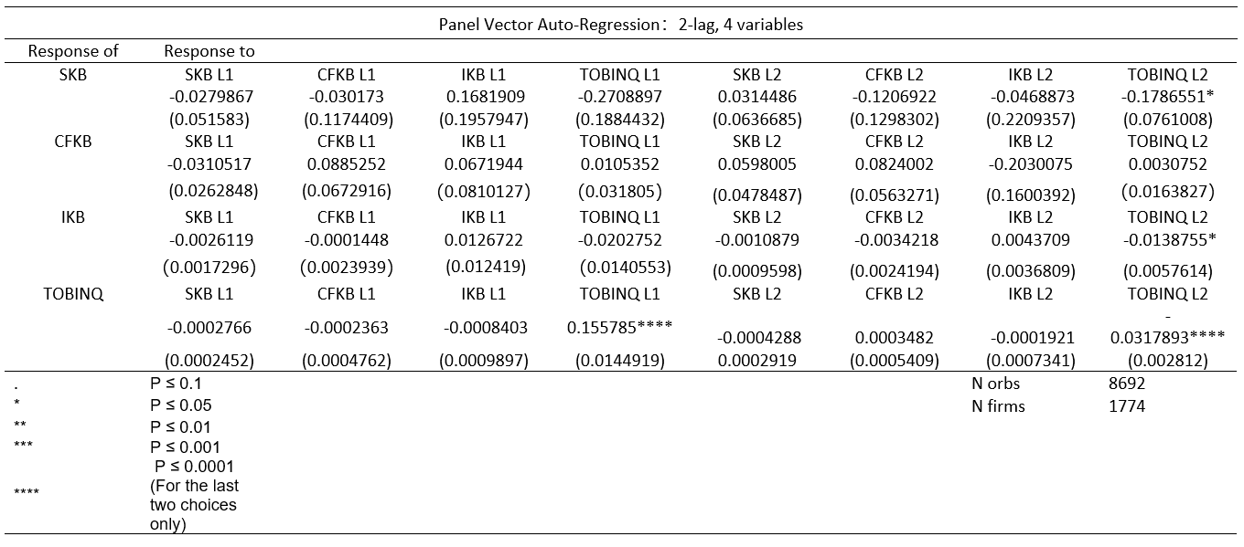Table 6

We estimate the coefficients of the 2-lag panel VAR system. In Table 6 we report the results of the model with four variables {**SKB**, **IKB**, **CFKB, TOBINQ**}. Unlike the 2-lag model with three variables, we do have some significant results in this model. First, SKB at time t is negatively correlated with TOBINQ at time t-2, which possibly means that if there is positive investment opportunities, firms will exploit them and marginal product of capital is likely to decrease after the opportunities are made use of after 2 periods. Also, IKB at time t is negatively correlated with TOBINQ at time t-2 as well, which is consistent with last result because firms will cut investment if marginal product of capital proxied by SKB is low. Lastly, it is observed that TOBINQ displays very strong self-correlation, positively with 1 period before and negatively with 2 period before, the latter agrees with above findings about SKB and TOBINQ, as well as IKB and TOBINQ.

3.4 Impulse-response functions

3.4.1 IRF graph for 3-variable model

Table 7



In Table 7 we present graphs of the impulse-response functions generated by Monte Carlo simulation. We can observe similar patterns as main panel VAR results here for correlations between SKB, CFKB and IKB. It is also noticeable from IRF graphs that, to our particular interest, a positive shock to CFKB results in a positive response from IKB, indicating that more internally available funds can stimulate investment. IKB also positively responds to shocks to SKB, which means companies increase their investment as expected when there is positive marginal product of capital. Negative responses from SKB to positive shocks in IKB are also intuitive that as more investment is enforced, marginal product of capital measured by SKB decreases. Additionally, all IRF graphs show signs of convergence as more intervals are incorporated.

3.4.2 IRF graph for 3-variable model

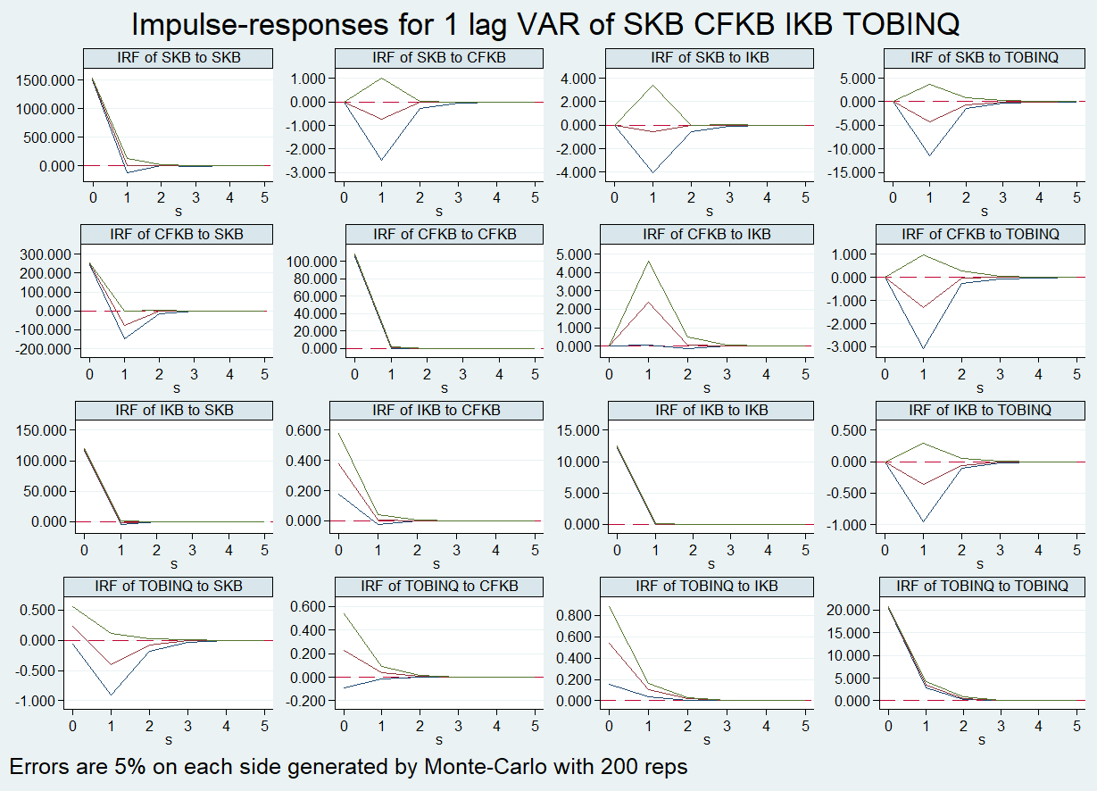Table 8

In Table 8 we present graphs of the impulse-response functions generated by Monte Carlo simulation. We can observe similar patterns as main panel VAR results here for correlations between SKB, CFKB and IKB. The 3x3 IRF graphs generated by the original three variables, SKB, CFKB and IKB stay unchanged. Furthermore, relationship between TOBINQ and other three variables can also be explored. It is clear that there exist negative responses from all other three variables to shocks to TOBINQ and that TOBINQ react positively to shocks to itself. Additionally, all IRF graphs show signs of convergence as more intervals are incorporated.

3.4 Variance decomposition

Table 9

|  |  |  |  |  |  |
| --- | --- | --- | --- | --- | --- |
| Forecast Error Variance Decomposition | | | | | |
|  | s | SKB | CFKB | IKB | TOBINQ |
| SKB | 1 | 1 | 0 | 0 | 0 |
| CFKB | 1 | 0.846 | 0.154 | 0 | 0 |
| IKB | 1 | 0.989 | 0 | 0.011 | 0 |
| TOBINQ | 1 | 0 | 0 | 0.001 | 0.999 |
|  |  |  |  |  |  |
| SKB | 2 | 1 | 0 | 0 | 0 |
| CFKB | 2 | 0.857 | 0.143 | 0 | 0 |
| IKB | 2 | 0.989 | 0 | 0.011 | 0 |
| TOBINQ | 2 | 0 | 0 | 0.001 | 0.999 |
|  |  |  |  |  |  |
| SKB | 3 | 1 | 0 | 0 | 0 |
| CFKB | 3 | 0.857 | 0.143 | 0 | 0 |
| IKB | 3 | 0.989 | 0 | 0.011 | 0 |
| TOBINQ | 3 | 0 | 0 | 0.001 | 0.999 |
|  |  |  |  |  |  |
| SKB | 4 | 1 | 0 | 0 | 0 |
| CFKB | 4 | 0.857 | 0.143 | 0 | 0 |
| IKB | 4 | 0.989 | 6 | 0.011 | 0 |
| TOBINQ | 4 | 0 | 0 | 0.001 | 0.999 |
|  |  |  |  |  |  |
| SKB | 5 | 1 | 0 | 0 | 0 |
| CFKB | 5 | 0.857 | 0.143 | 0 | 0 |
| IKB | 5 | 0.989 | 0 | 0.011 | 0 |
| TOBINQ | 5 | 0 | 0 | 0.001 | 0.999 |

The variance decompositions for the system of intervals of 5, presented in Table 9, are in line with these results. SKB is solely forecasted by itself while it can largely forecast both cashflow and investment (around 0.85 and 0.99) in the next period. CFKB and IKB show very few variations (around 0.15 and 0.01) that can be explained by themselves. TOBINQ is almost solely (0.999) self-forecastable. It is noted that the results of variance decompositions show also signs of convergence with more intervals with same patterns of s=2, 3, 4, 5.

**4. Conclusion**

This paper uses a **panel VAR**, with 2 panel VAR models: 3-variable and 4-variable, approach to analyze the relationship between 4 firm-level variables **SKB**, **CFKB**, **IKB** and **TOBINQ**. It shows that there is statistically significant evidence for a 1-lag negative correlation between SKB and CFKB, a 1-lag positive correlation between IKB and CFKB, a 2-lag negative correlation between SKB and TOBINQ, IKB and TOBINQ and a positive self-correlation of TOBINQ . More information from **impulse-response function** graphs indicates more intuitive responses, such as positive responses in IKB to shocks in CFKB, negative responses in TOBINQ to shocks in IKB. Results from variance decompositions illustrate that SKB is the driving force in forecasting SKB, CFKB and IKB while variations in TOBINQ are almost solely attributable to itself.

However, it is obvious that though results in some anticipated directions are achieved, a pivotal lack of significance of the majority of the results is not desirable. There are various reasons for such flaws. Possibly it is because that the dataset adopted contains completely different companies from completely incommensurable industries. Another extrapolation could be that firms included in the dataset have a wide range of disparate degrees of accessibility to external financing, such as security, bond issuance and bank loans, which is why there is not a significant correlation between CFKB and IKB, indicating the relationship between investment decisions and availability of internal funding as per Love’s literature. The possibility of variations caused by ownership of companies is not negligible either, especially when studying Chinese firms. State-owned, private-owned and foreign-owned companies operate in entirely different ways in terms of financing, decision-making and management.

Consequently, further sorting companies in the dataset into different categories and echelons according to different standards, such as industries, accessibility to external financing and ownership, could, therefore, largely abate such problems and present much more significant results and this is exactly what is needed to be done as the next step.

**References**

Love, I., & Zicchino, L. (2006). Financial development and dynamic investment behavior: Evidence from panel VAR.

*The Quarterly Review of Economics and Finance* 46 (2006) 190–210.

# Mukher, S. The Neoclassical Theory of Investment (With Diagram).

*Economics Discussion*: http://www.economicsdiscussion.net/investment/neoclassical-theory/the-neoclassical-theory-of-investment-with-diagram/10383

Wikipedia. Vectorautoregression: https://en.wikipedia.org/wiki/Vector_autoregression

Wikipedia. Impulse response: https://en.wikipedia.org/wiki/Impulse_response